Read and paint.
A black pencil case  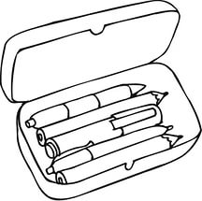 | A red book  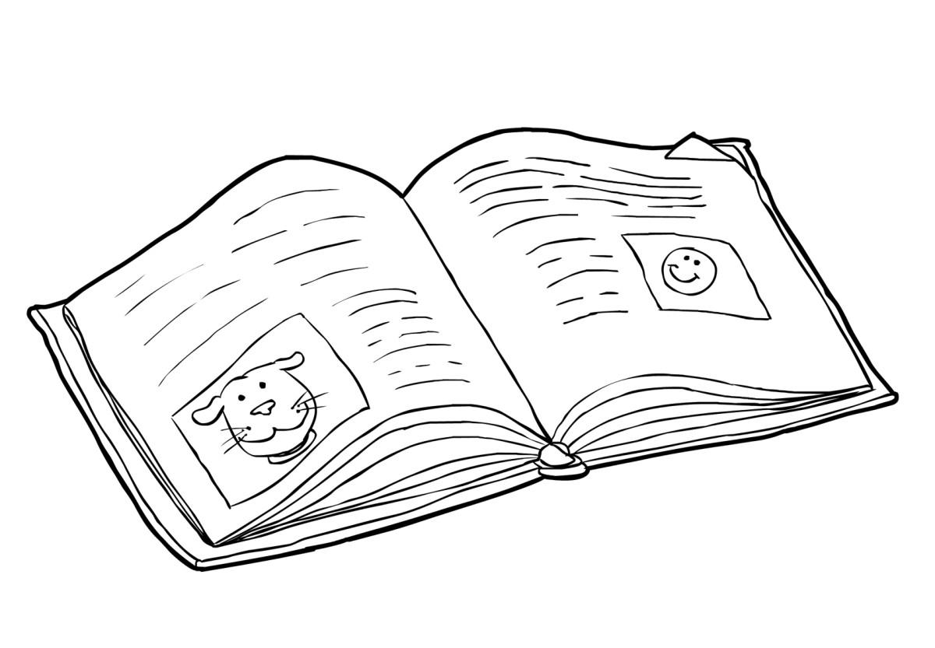
Read and draw.

an orange pencil | a green pen
a brown exercise book | a pink ruler
a purple rubber | an orange school bag
a yellow book | a blue pencil case
Read and paint.
A black pencil case | A red book
Read and draw.

an orange pencil | a green pen
a brown exercise book | a pink ruler
a purple rubber | an orange school bag
a yellow book | a blue pencil case

